|  |  |
| --- | --- |
| A close up of a typewriter | WEB advanced technologies |
| Project Name: | Interactive Infographics Website |
| Group: | WEB HW2 – Group9 |

How we assigned the tasks: The tasks were divided according to each participant skills on the topic, below is each participant details and the assigned tasks he got.

|  |  |  |
| --- | --- | --- |
| Participants | | |
| Name | Assigned Tasks | Completed Tasks |
| Rabea Lahham  (System Engineer) **209318419** | Chart Page Component  +  Improve the design | Chart Page Component  +  Improve the design |
| Bahalden Sweed **207659392** | Create Page Component +  Scroll down feature in home page | Create Page Component +  Scroll down feature in home page |
| Tamer Amer **207418583** | Create Page Component  +  Web architecture | Create Page Component  +  Web architecture |
| Mbada Shehady **212800080** | Register Form in home Component + Use Case | Register Form in home Component +  Use Case |

Web architecture:

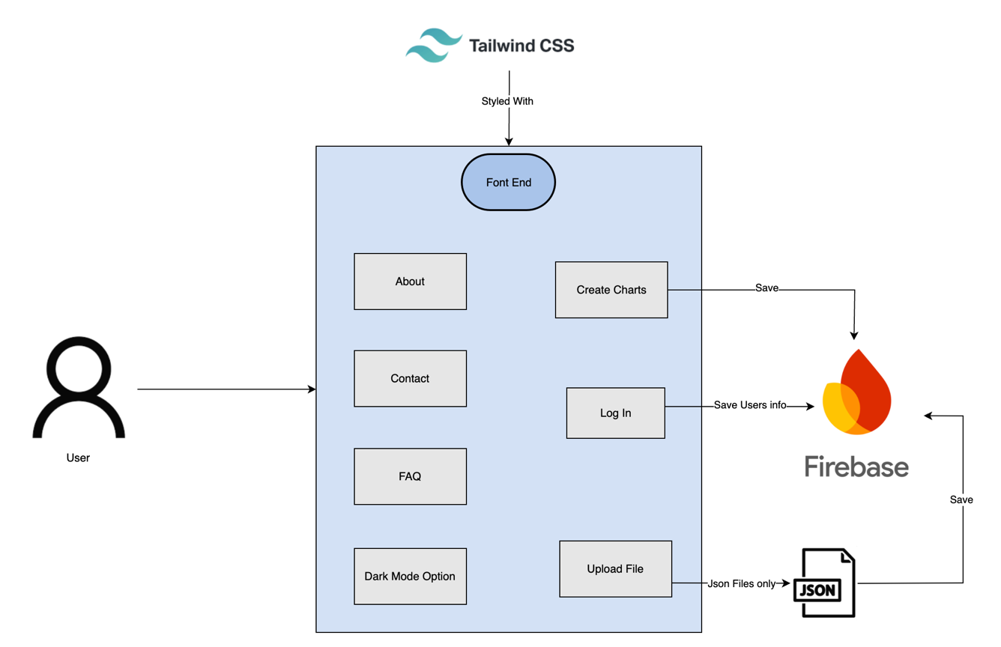

Use Case Diagram:

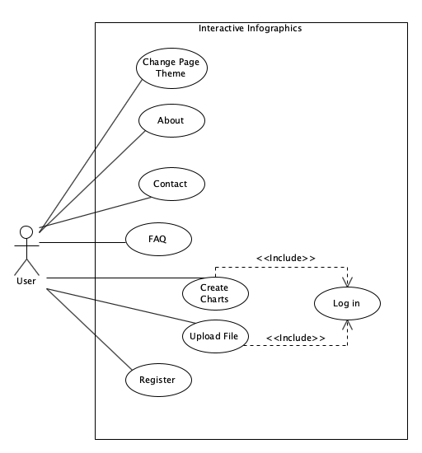

|  |
| --- |
| Project resources |
| 1. HW2 project Link: 2. HW2 Project Github repository: https://github.com/oRABiiA/WEB-HW2.git   **Note:** We included in the Github repository JSON files to test the upload of a json file & to understand the how the format will be. |